**Moving Repository to different Drive**

ETAS/ICO

**Step 1:**

To find the size of the repository go to below folder D:\ScheduledTasks\RepositorySize\PropOfAllFiles_output

and open the latest file.

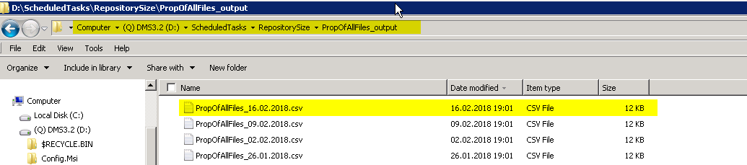

**Step 2:**

Copy this file to local PC and open it using excel and give the headers to each column and apply filter.

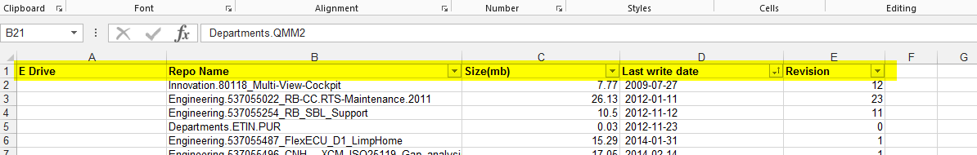

**Step 3:**

Check for the oldest and biggest size of the repository to move to other drive.

**Step 4:**

Copy the selected Repository from D: drive to E:drive

For ex: Copying Departments.QMM2 from D to E drive.

Once copied delete the repo Departments.QMM2 from D drive.

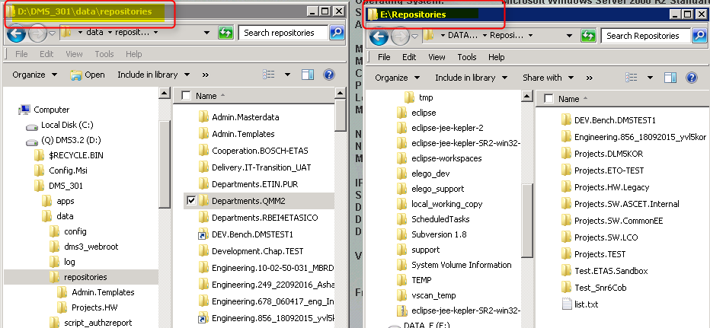

**Step 5:**

Now create a mklink as shown below.

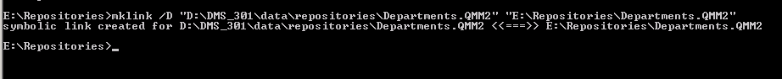

Hence the link has been created and repository is hosted in E drive now.

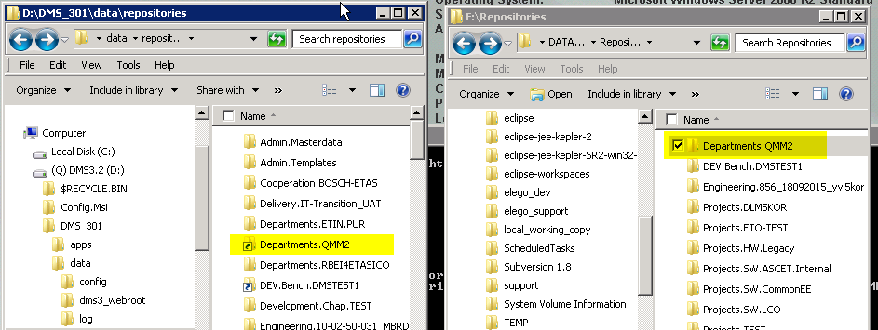

**Extra Information:**

In PROD server link has been created from D drive to F drive, Now that F drive is full we need to follow some additional steps to get the detailed info:

First get the Repo size details from D:\ScheduledTasks\RepositorySize\PropOfAllFiles_output and copy the latest file into your local machine.



Then go to F drive and get the linked repos by running the below command in command prompt (open the cmd prompt in admin mode)

cid:image006.png@01D3ACB8.09F075B0

Check for this list which has all repos name and copy that list in sheet 2 of PropOfAllFiles_16.02.2018.csv

Then insert a column in the excel sheet and write formula as =(COUNTIF→go the Sheet 2 and select the range press F4 and enter ; and then select the column 2 of first sheet)

You will be getting the value 0 or 1 , 1 means the repo has link to F drive and based on that select the oldest and biggest Repo from f drive to move to drive which has free space and then create a mklink from D drive to the drive where the repo has been copied.